Highly Privileged Access (HPA) User List Extraction - <APPNAME>

Below is the SQL query used by Donald Webber to extract highly privileged accounts for the application CTD. The query extracts all highly privileged accounts from the Oracle SQL developer, includes all types of users who have access to the application. The query result produces a complete and accurate listing of all highly privileged users to the best of our ability. As on 8/26/2014, the query fetched 17 users having access to this application and I confirm that the users list is complete and accurate
Below is the query used to extract the highly privileged accounts.
select a.user_code,b.role_code,a.first_name,a.last_name,a.email_address from ctd_user a, ctd_user_role b where a.ACTIVE_IND = 'Y' and a.user_code =b.user_codeand role_code in ('SYSADMIN','EASYSADMIN')
The query extracts 17 Highly privileged accounts from the application.
Query Results:
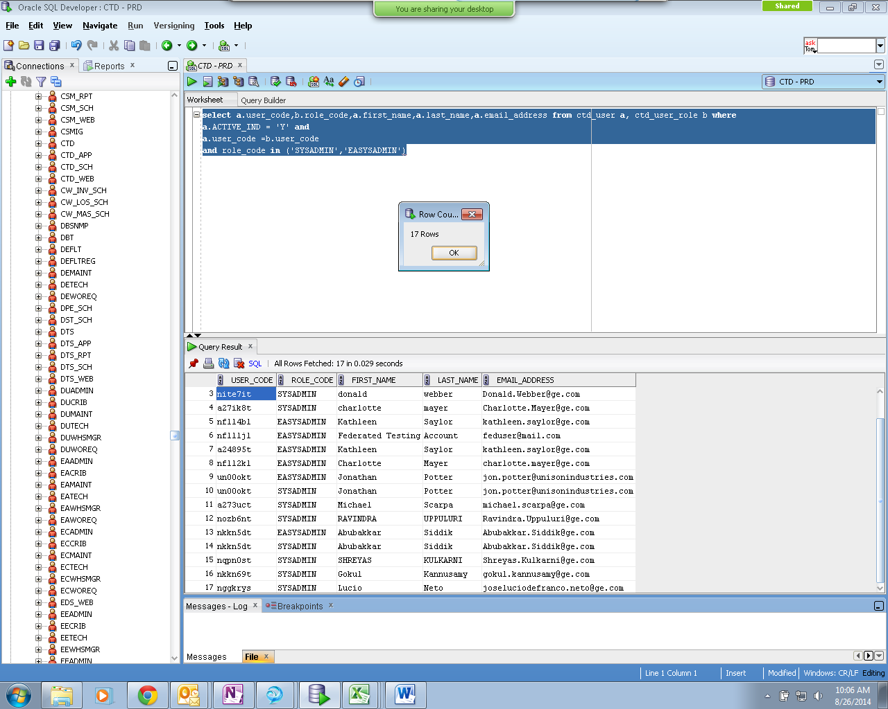
Provides the total no. of users extracted.

Below snap shot shows the date and time of HPA extraction
Attached is the HPA user list in excel format with authorized owner information.

